# Paper/Part Two – Eulerian and Lagrangian measurements of flow and residence time on a fringing reef flat embayment in American Samoa

**Intended journal:** [**Coral Reefs**](http://www.springer.com/life+sciences/ecology/journal/338)**, Impact Factor: 3.66 (2012)**

## Introduction

**Importance of hydrodynamic processes on coral reef sediment dynamics**

Hydrodynamic conditions on coral reefs are important for biologically important processes like nutrient cycling, larval dispersal, and temperature regimes (Falter et al., 2004; Wyatt et al., 2012), and are a primary control on sediment dynamics in fringing reef embayments (Draut et al., 2009; Storlazzi et al., 2009). Current conservation planning is done with estimations of pollutant discharge and distance-based plume models (Klein et al., 2012) but coral reef environments are more hydrodynamically complex and variable than estuaries or beaches. Studies in Hanalei Bay showed that variations in reef morphology relative to the orientation of the dominant meteorological and oceanographic forcing can generate heterogeneous waves and currents over relatively small (hundreds of meters) spatial scales, unlike those observed along relatively linear sandy shorelines (Hoeke et al., 2011; Storlazzi et al., 2009). Hydrodynamic conditions can control sediment dynamics both by flushing suspended sediment away from corals before deposition, and resuspending and removing previously deposited sediment (Hoitink and Hoekstra, 2003; Presto et al., 2006). In reef environments where shallow reef crests limit the propagation of incoming surface wave energy, wave action alone may be insufficient to resuspend and disperse sediment, but in combination with wave- or wind-driven currents, orbital velocities may reach critical shear stress for sediment resuspension and dispersal (Ogston et al., 2004). By influencing orbital velocities, bed shear stress, suspended sediment transport, and water residence time, hydrodynamic conditions are a strong control on the spatial distribution of sediment deposition, resuspension, and dispersal of terrigenous sediment discharged to the reef (Hoitink and Hoekstra, 2003; Presto et al., 2006; Storlazzi et al., 2004).

**Water circulation forcing processes**

Studies in various coral reef environments adjacent steep, volcanic islands showed current speeds, directions, and residence times over reef flats are controlled by wave, wind, and tidal forcing, depending on the orientation and morphology of the reef, relative to the prevailing wave, wind, and tidal climates (Hench et al., 2008; Hoeke et al., 2011; Presto et al., 2006; Storlazzi and Jaffe, 2008; Storlazzi et al., 2004). Buoyancy forcing from hypopycnal river floods is generally ignored or considered inconsequential due to their rarity and short duration relative to other forcings (Hench et al., 2008; Hoeke et al., 2011). Current speeds and patterns over reefs exposed to remotely-generated groundswells are generally dominated by wave forcing (Hench et al., 2008; Hoeke et al., 2011; Vetter et al., 2010), whereas wind forcing is dominant over reefs protected from groundswells (Presto et al., 2006; Storlazzi et al., 2004). Tidal forcing is considered minor in microtidal environments, however, tidal elevation modulates both wave- and wind-driven currents, by controlling the propagation of wave energy over the reef crest, and by regulating water depth for wind-driven surface wave development (Presto et al., 2006). Reef flat currents in wave-driven environments exhibit a pattern of rapid, cross-shore flow near the reef crest that slows and turns along-shore towards a deep channel where water returns seaward, limiting cross-shore exchange of sediment from the reef flat to the forereef (Hench et al., 2008; Lowe et al., 2009; Wyatt et al., 2010). In wind-driven systems, current directions are more predominantly in the direction of the wind with possible cross-shore water and sediment exchange from the reef flat to the forereef (Storlazzi et al., 2004), distributing sediment impacts from the muddy reef flat to the forereef (Presto et al., 2006). Observations on the wind-dominated reef flat in Molokai, Hawaii, showed current speeds were faster where the reef is deeper and narrower (Storlazzi et al., 2006c) but field observations at the wave-dominated proposed study site suggest the opposite; current speeds are rapid over the shallow reef crest, slowing significantly when reaching deeper pools in the reef and the main channel that bisects the reef.

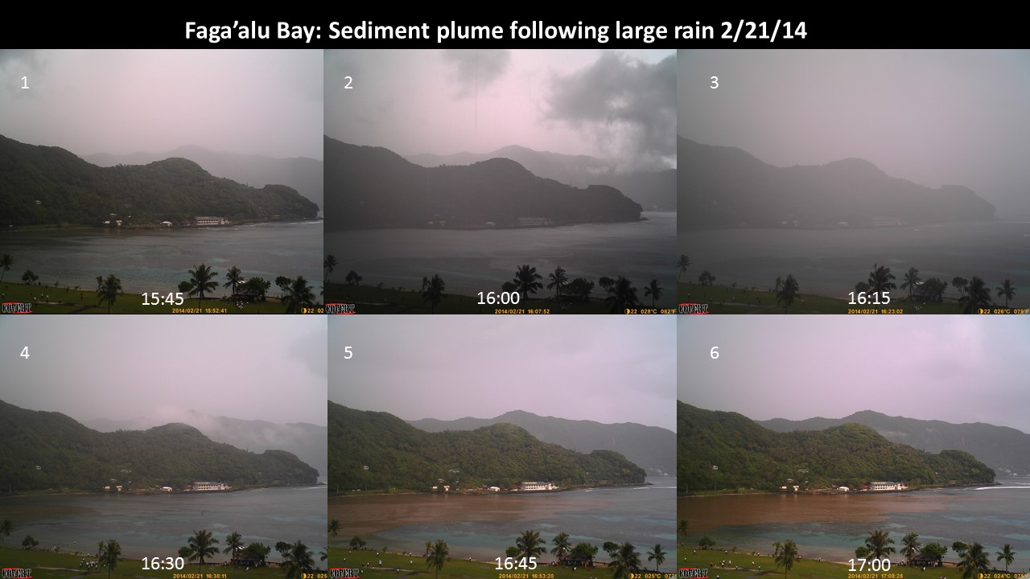

Figure 1. A sediment plume following a rainstorm in Faga'alu Bay 2/21/14. Waves breaking on the southern reef crest (to the bottom right) drive flow across the southern reef flat, deflecting the sediment plume northward (to the upper left), limiting sedimentation on the southern reef, and focusing sediment stress on the northern reef

**Sediment plume dynamics in Faga’alu**

Understanding the current speeds, flow patterns, and residence time of water over the reef flat is critical for understanding spatial and temporal patterns of sedimentation in the study site, Faga’alu Bay, American Samoa. Following large or intense storm events, suspended sediment is discharged into Faga’alu Bay and advected seaward over the reef by momentum, in a thin surface layer of high suspended sediment concentration (SSC)(>500mg/L)(Figure 1). This sediment-rich layer attenuates photosynthetically active radiation (PAR; Piniak and Storlazzi, 2008, ECSS) and transports fine-grain sediment over the reef where it can settle out of the water column and onto coral organisms. Although the hypopycnal surface plume is able to move counter to prevailing currents (upcurrent) by sliding over denser seawater, as sediment particles settle they are entrained in the prevailing current and transported accordingly (Wolanski et al., 2003). As flow velocities increase, residence time of the plume over the reef flat decreases, limiting time for small particles to settle out of the water column and controlling the sedimentation rate, even for the same concentration and magnitude of different plumes. In general, field observations (Figure 1) suggest the sediment plume following rain events is deflected north, limiting sedimentation on the southern reef, and focusing sediment stress on the northern reef.

**Previous Research in American Samoa**

Little data on current circulation around Tutuila is available, and almost no data on circulation over the reef flat has been collected (CH2M HILL, 1984; Jacob et al., 2012; Wiles et al., 2012). Militello et al. (2003) modeled wave-induced setup on reef flats and developed stage-frequency relationships for large tropical storms and hurricanes in American Samoa. Thompson and Demirbilek (2002) characterized offshore wave climate from data collected near Western Samoa (1985-1990), and used numerical modeling to simulate wave propagation dynamics in Pago Pago Harbor. Vetter et al (2013)(unpublished) deployed wave/tide gauges in Faga’alu Bay on the southern forereef and reef flat, and an ADCP in the deep channel bisecting the reef crest, for one year (2012-2013). Vetter (2013) concluded flow dynamics in the bay were predominantly forced by waves breaking over the southern reef crest, and the wave influence increased linearly with tide height. Using an estimate of total lagoon volume, Vetter (2013) calculated flushing time varied from thirty-three hours during low wave height, to less than two hours during conditions when peak wave height was 1.6m, and mean current speed out of the main channel was 0.14 m/sec.

## Part Two Research Questions

The research questions for this paper are:

1. What is the residence time of ocean water over the northern and southern reef flats?
2. How are current speeds, flow patterns, and residence time affected by wave-, wind-, and tidal-forcing?

## Study Site

Faga’alu Bay, Tutuila, American Samoa (14.290738° S, 170.677836°W) is a V-shaped, reef-fringed embayment at the mouth of a small, steep-sided watershed (2.48 km2)(Figure 2). An anthropogenically altered, vertical-walled, 10-20m deep paleo-stream channel (‘ava in Samoan language) extends from the mouth of Faga’alu Stream eastward to Pago Pago Bay. This deep channel divides the reef into a larger Southern and a smaller Northern section. A microtidal regime varies semi-diurnally from approximately 0 to 1m, exposing parts of the shallow reef crest and reef flat at extreme low tides (<0m MSL).

Faga’alu Bay is situated on the western side of Pago Pago Bay, where it is protected by land from incoming swell from all directions except from the south to the east-south-east. The surrounding high topography blocks wet-season northerly winds (October-April), but the bay is exposed to dry-season southeasterly tradewinds and accompanying short-period wind waves (May-September). Faga’alu is only open to a narrow window of swell directions (S-SE) and swells approaching from a southerly angle refract to the west to break directly on the reef, reducing the energy of breaking waves. Offshore, significant wave height (Hs) from southerly and southeasterly directions are generally less than 2.5m and rarely exceed 3m. Wave periods (Tp) are generally about 9 s or less, rarely exceed 13 s but occasionally reach 25 s (Thompson and Demirbilek, 2002). Vetter (2013) recorded peak significant wave heights on the forereef in Faga’alu up to 1.7m, but wave heights greater than 1 m were rare (Figure 3). Given that the reef crest is nearly exposed at low tide, cross-reef transfer of water and wave energy is strongly dependent on the tidal stage and wave setup.

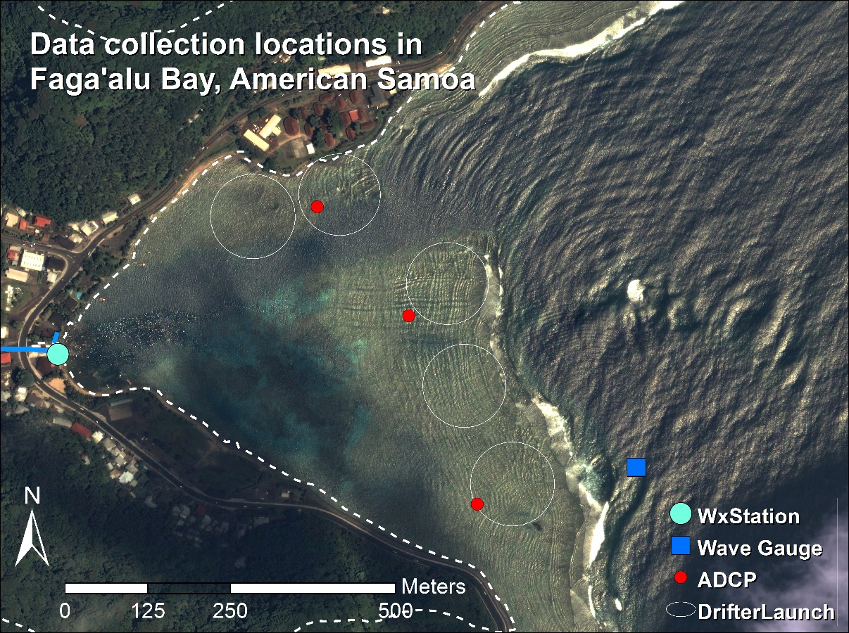

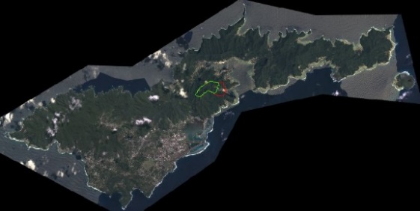

Figure 2. Data collection locations in Faga'alu Bay. Wind speed and direction was recorded at the weather station (WxStation), a Dobie wave gauge recorded wave height and period (Wave Gauge), three ADCP’s were deployed for one week to measure current speed and direction, and five GPS-logging drifters were deployed from the same five launch zones (DrifterLaunch) for thirty separate deployments (January to March, 2014).

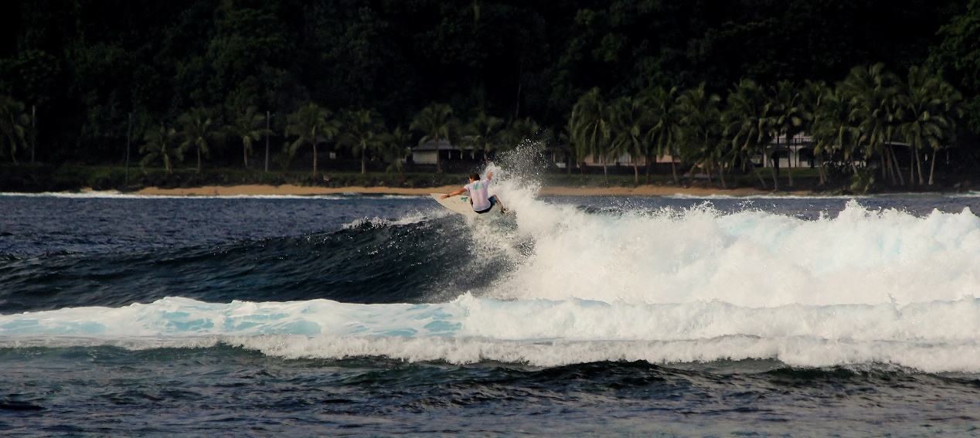

Figure 3. According to wave gage data, significant wave heights on the southern reef crest rarely exceed 2m but have been observed several times in the field coinciding with smooth seas and light winds in the wet season. Author included in photo for scale. Photo: Robert Koch, Am. Samoa Coastal Zone Management Program (ASCMP)

## Methods

While Vetter (2013) used wave/tide data and current speed in the main channel to calculate flushing time, those calculations are highly dependent on the estimation of total volume in the bay and are reliant on bathymetric data which is not well verified. Calculations of flushing time based on a few point measurements of current velocity also do not provide information on the spatial distribution of flow speeds or specific flow paths over the reef. Since it is known that residence time of water, in addition to water quality, is a strong control on coral health, it is desirable to characterize spatially distributed residence times in relation to wave, wind, and tide forcing.

**Eulerian vs. Lagrangian methods**

To characterize the flow pattern over the reef flat in Faga’alu Bay, and to determine the relationship between wave- and wind-forcing and residence time of water over the reef flat, a combination of Eulerian and Lagrangian measurements was used. In fluid dynamics there are two ways to quantify the flow field: 1) the Lagrangian perspective observes an individual fluid parcel as it moves through space and time, 2) the Eulerian perspective focuses on specific locations, observing the fluid flowing past that location over time. Eulerian methods typically characterize water circulation on the reef using bottom-mounted instruments to record wave height and period, current speed and direction, and/or tidal elevation (Presto et al., 2006; Storlazzi et al., 2009). Collecting high spatial resolution data of hydrodynamic processes using strictly Eulerian methods is expensive and logistically difficult (Storlazzi et al., 2006b, 2004). While remote sensing is useful to map the temporal and spatial distribution of flood plume boundaries (Klemas, 2012; Warrick et al., 2007), the underlying current circulation is a strong control on sediment transport that may not be quantified by even high resolution remote sensing of plumes. Spatially distributed wave height, current speeds, and flow patterns can be predicted by hydrodynamic computer models (Hoeke et al., 2011), but models typically require accurate bathymetry, detailed forcing data, and significant modeling expertise (Hoeke, 2010; King et al., 2012; Wolanski et al., 2009). Lagrangian methods including the use of GPS-tracking drifters have been used to map flow patterns over reef flats to compare to Eulerian descriptions of flow speeds (Storlazzi et al., 2006a, 2004; Wyatt et al., 2012) or validate hydrodynamic computer models (Ouillon et al., 2010).

**Progress in using Lagrangian drifters**

GPS-tracking drifters have been traditionally used to characterize oceanic circulation in the deep or coastal ocean (Davis, 1991; Warrick et al., 2007), but less expensiv, smaller GPS technology has recently made it possible to deploy many (n≥10) small drifters in nearshore environments to map flow patterns at finer spatiotemporal resolution (Austin and Atkinson, 2004; Johnson et al., 2003; MacMahan et al., 2010; Storlazzi et al., 2006a). Research on rip currents in beach surf zones have shown the ability to capture synoptic measurements of small-scale flow structures and patterns by deploying large numbers of GPS-logging drifters to collect high-density observations of flow speeds and directions (Johnson et al., 2003; MacMahan et al., 2010). Although deploying a fleet of GPS-logging drifters has yielded synoptic measurements of water movement in surf zones near linear, sandy beaches, it has not been attempted in a shallow reef environment.

**Combining Eulerian and Lagrangian measurements**

Drifter studies in nearshore environments are typically limited in number of drifters, number of deployments, and/or the range of oceanic and meteorological conditions experienced during deployments, making it uncertain whether they describe the dominant patterns, or short-lived anomalies (Storlazzi et al., 2006a; Wyatt et al., 2010). While Lagrangian measurements provide spatially explicit data on the flow field, observations are limited temporally by their short duration times relative to Eulerian methods like in situ current meters. Storlazzi et al., (2006) compared Lagrangian drifter tracks with long-duration Eulerian current meter records to determine if short-term Lagrangian observations from drifters were representative of the dominant climatic patterns.

**Analysis of “end-member” forcing conditions**

Current speed and direction data from three Acoustic Doppler Current Profilers (ADCP), providing Eulerian measurements, were deployed for one week and five GPS-logging drifters, providing Lagrangian measurements, were deployed approximately 30 times over two months, will be categorized according to end-member condition, with categories being “Wave-driven”, “Wind-driven”, and “Calm” (Hoeke et al., 2011; Presto et al., 2006). Under calm conditions, forcing is assumed to be attributed to tidal movement (Presto et al., 2006). If relationships between current speed and/or direction and wave-,wind-, or tidal-forcing are weak, data can further be subdivided by wind direction and tidal stage. Each GPS point recorded by the drifter is considered an independent observation, and drifter velocities and trajectories are calculated using a forward-difference scheme on the drifter locations (Davis, 1991; MacMahan et al., 2010). Given a high density of observations, drifter tracks can be binned as long as the bins are smaller than the scale of the flow structure to be observed (Davis, 1991). Drifter tracks will be binned by location (100 m x 100 m grid cells) and averaged over the time of deployment (MacMahan et al., 2010), yielding a grid of arrows pointing in the mean flow direction, sized by speed, and colored by number of observations, similar to Figure 4. Residence times will be calculated as a function of average flow speed through the 10m grid cell.

To determine if the short-term drifter deployments adequately describe long-term forcing conditions observed by the ADCP, two techniques are used to compare the drifter results with ADCP results: Empirical orthogonal functions (EOF) and progressive vectors of cumulative flow. EOFs determine the dominant modes of flow in the spatial domain, and the observed patterns at any given time period are described as a linear combination of the different modes (Emery and Thomson, 2004). EOFs and variance ellipses can also be calculated for binned drifter data and compared to calculations from ADCP data (MacMahan et al., 2010). Variance ellipses are commonly calculated from ADCP data to describe the relative magnitude of flow direction in the cross- and along-shore directions, and show the coherence of the flow: how strongly it flows in one direction, or if it is more variable (Hench et al., 2008; Hoeke et al., 2011; Storlazzi et al., 2006c). Progressive vectors from the ADCP measurements will also be calculated, and compared to drifter tracks (Storlazzi et al., 2006a).

To determine the relationship of residence time and wave-, wind-, and tidal forcing, regressions are calculated between forcing data and residence time (calculated from current speeds categorized by end-member conditions and binned over the north and south reefs) (Lowe et al., 2009).

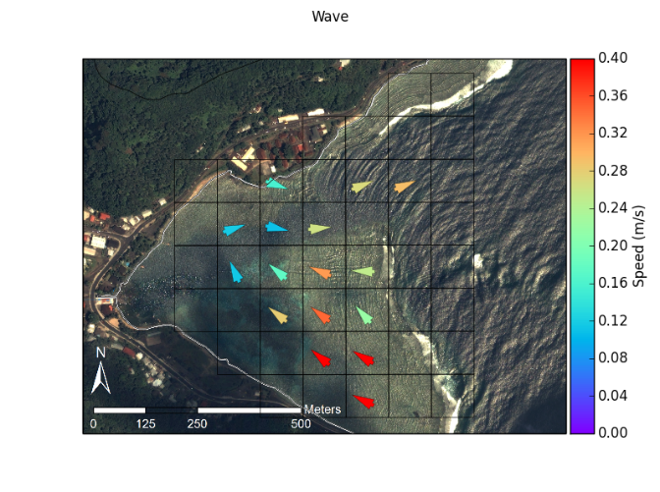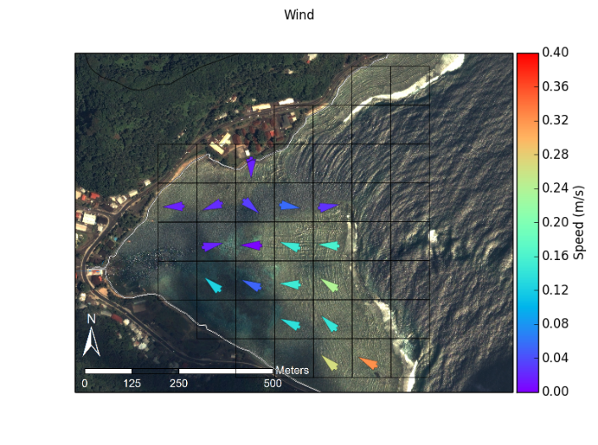

Figure 4. Drifter tracks during various “end-member” forcing conditions are binned by 100 m x 100 m grid cells and averaged.

## Field Data Collection

### Wave, Wind and Tide data

A NIWA Dobie-A wave/tide gauge (DOBIE) was deployed on the southern reef slope at 10m depth, and recorded in 512 second bursts at 2Hz at the top of every hour. The DOBIE malfunctioned and recorded no data coinciding with the ADCP deployment, but showed good comparison with NOAA WaveWatchIII (WW3) modeled data on swell height and direction. Swell height and direction output from WW3 will be used to characterize wave forcing in the analysis of the ADCP data and to define the endmembers for each measurement date (Hoeke et al., 2011).

Meteorological data during the study were obtained from a Davis VantagePro weather station installed near the stream mouth, approximately 5 m above sea level on a pole mounted to a building (WxStation, Figure 2). Wind speed, wind direction, barometric pressure, and precipitation were recorded at 15 min intervals. Meteorological and tide data were also recorded at a NOAA NDBC station (NSTP6), 1.8 km north of the study area. Wind speed, wind direction, barometric pressure, and water level were recorded at NSTP6 at 6 min intervals. For this study, wind conditions are sufficiently described qualitatively so the topographic effects on wind speed and direction recorded at the stations are considered inconsequential (Storlazzi et al., 2004).

### Eulerian and Lagrangian flow measurements

**Acoustic Doppler Current Profilers (ADCP)**

Three Nortek Aquadopp ADCP were supplied by the USGS Pacific Coastal and Marine Science Center in Santa Cruz, CA, and deployed on the reef flat in Faga’alu for one week: 15-23 February, 2014 (Figure 2; Figure 5). Flow speed and direction were recorded every 20 min at 1 Hz (not sure what the actual specs were, Curt programmed them). On the Northern reef the water level dropped below the minimum blanking distance of the ADCP at low tides, and flow is assumed to be nearly zero during these times given the relatively low water depth.

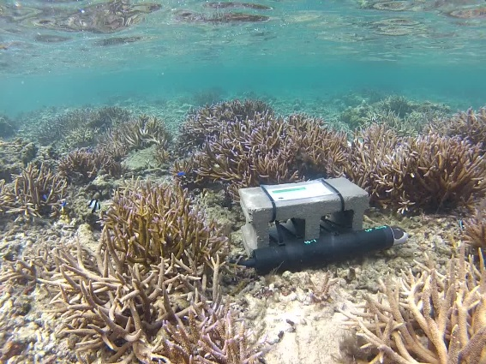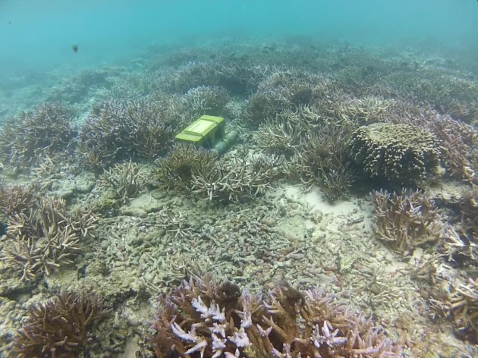

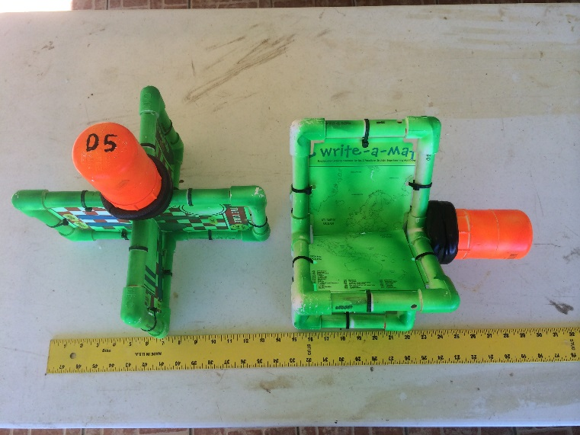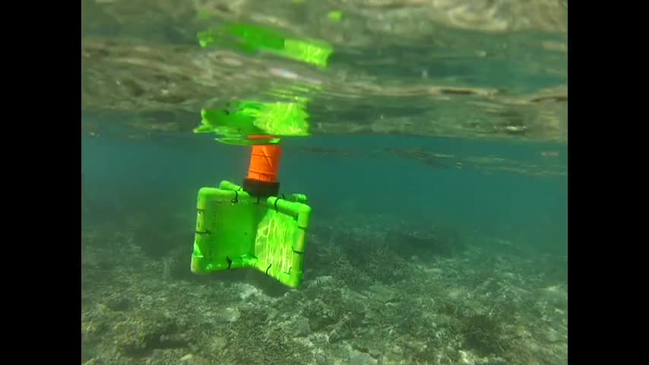

Figure 5. ADCP and drifter deployment.

**GPS-logging Drifters**

Drifter designs typically involve the use of a suspended drogue (Johnson et al., 2003; Ouillon et al., 2010) or a finned tube (MacMahan et al., 2009) to extend into and anchor the drifter in the water column. However, due to the shallow conditions experienced on reef flats a novel drifter design was needed. Drifters for shallow coral reef environments need to be shallow enough to avoid interaction with corals, deep enough to not be affected by the surface movements, extend high enough to be visible but not high enough to be affected by winds, and finally, rugged enough to sustain the impact of a breaking wave onto corals in the event it is entrained in the surf zone.

Faga’alu Bay is a relatively small area (0.25km2) so very high density drifter data could be collected with a small number of drifters (n=5) and field personnel (n=1). Five drifters were designed and constructed on-island, from PVC tubing and plastic sheeting, with a small waterproof housing for the GPS recorder (HOLUX M1000), and a float collar to maintain upright orientation (Figure 5). Deployments were conducted opportunistically to capture “end-member” conditions for all combinations of High-Low waves, High-Low wind (offshore and onshore), and High-Low tide. Multiple daily deployments were scheduled during one randomly selected week coinciding with ADCP deployment to facilitate direct comparisons of Eulerian and Lagrangian flow measurements under various forcing conditions. Thirty deployments were conducted, with twenty-two of those deployments coinciding with ADCP deployment.

## Expected Results/Outcomes

It is hypothesized that under low wave conditions, mean flow directions are more variable and mean flow speeds are lower. Under high wave conditions, mean flow patterns are more coherent in a single direction at a given point and mean flow speeds are greater. Flow patterns are less variable near the reef crest, and more variable on the reef flat, especially the northern reef flat. These hypotheses will be tested by variance ellipses calculated from spatially binned ADCP and drifter data, categorized by end-member forcing condition.

It is hypothesized that residence time of water over the northern reef will be longer than over the southern reef, despite the much smaller area of the northern reef, because wave exposure and resulting flow speeds are lower. This hypothesis will be tested by averaging residence time in each 10m x 10m bin over the north and south reefs under end-member conditions, and comparing their relationships with wave-, wind-, and tide-forcing.

The resulting empirical model of residence time over the northern and southern reefs will be used as a component of a top-down model of sedimentation on the reef developed in Paper Three. This study also tests a novel drifter design for use in shallow, coral reef environments, and provides a novel dataset of reef circulation from high spatial density drifter observations over a significant range of wave and wind-forcing conditions.